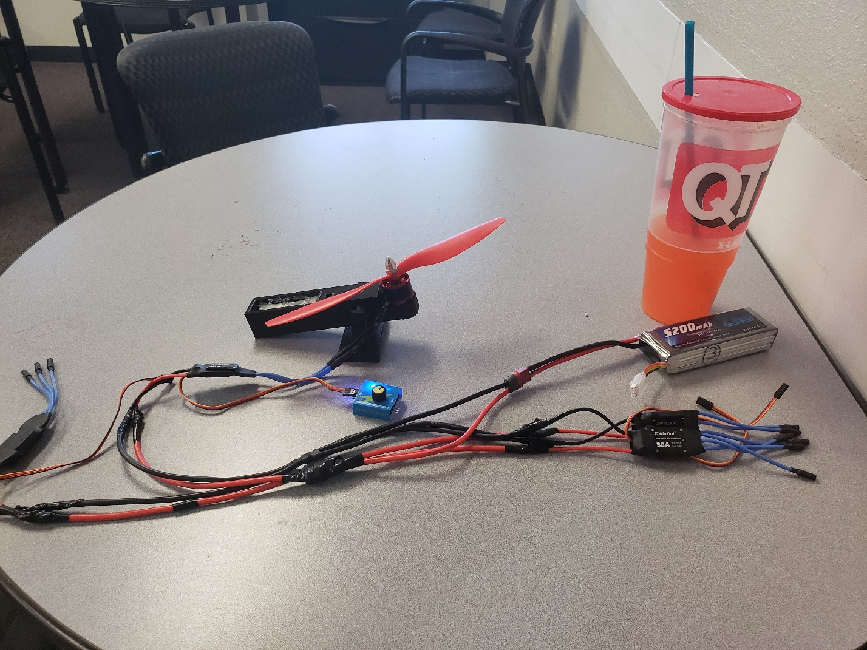

My thrust measurements are

330 g

312 g

300 g

The average is

314 g